Validation Report for ISO/IS 10303-238

Document wg3n2098
(supersedes wg3n1538)

David Loffredo
loffredo@steptools.com
2006-07-14
Contents

1 Introduction 2
2 AAM, ARM and ISO 14649 3
2.1 ARM Validation 4
2.2 Turning Model 6
2.3 EDM Model 8
3 Usage scenarios and usage tests 8
4 Integrated resources interpretation 10
4.1 AIM Document Change History 11
4.2 General Mapping Issues 26
4.2.1 Short form Use/Reference 26
4.2.2 Actions and Action Methods 26
4.2.3 Subtypes and Naming Conventions 27
4.2.4 Subtypes of Relationships 27
4.2.5 String Values 28
4.2.6 Properties and their Representation 28
4.2.7 Measures, Units, and Tolerances 29
4.2.8 Pressure and Speed measures 31
4.2.9 Spindle, Feed, and Dwell measures 32
4.2.10 Shape Representations 34
4.2.11 Expressions and Properties 34
5 AIM validation 35
5.1 AP238 CC3 Milling Testing at General Dynamics Land Systems (GDLS) August 2001 36
5.2 AP238 CC3 Multi-Axis Milling Testing at NASA Jet Propulsion Lab, January 2003 38
5.3 AP238 CC1 Testing for 5-Axis Machining, February 2005 39
5.4 AP238 CC2 Testing for Closed Loop Machining, May 2005 40
5.5 AP238 Aerospace Demonstration, Toulouse June 2006 44
5.6 Other AIM validation 46

Introduction
The ISO 6983/RS274D language for Computerized Numerical Control (CNC) programs is 40 years old. It was designed for an era when paper tape was the most popular medium for moving data between computers and the logic necessary to process simple commands was barely affordable for a CNC machine. Today the average microprocessor can easily process 3D data and NC programming is the only function in the design to manufacturing process that is not using full fidelity 3D information.
AP238 defines a modern data input standard for CNC systems that includes richer, more complete 3D information. This will make developing a CNC part program more efficient because the machining instructions can be defined more concisely. CNCs can also use this richer information to optimize and check a part program for the tooling available at the time of manufacturing instead of having it fixed at the time of planning. An AP238 data set describes all that the shop floor needs to know about the product and the process including all the required tolerances, so drawings will no longer be required on the shop floor.
The activity model and information requirements behind AP238 have been standardized separately as ISO 14649. These models were originally developed by a joint European and Japanese project. The first model they produced was for the data necessary to the control milling machines. These machines remove material by moving a cutting tool across a part. The leading developers of the milling model represented Siemens, the University of Aachen and the University of Stuttgart in Germany, Komatsu and Fanuc in Japan and Heidenhein in Switzerland.
The ISO 14649 information models describe the information requirements as an object model using the EXPRESS language. AP238 uses this as the AAM and ARM and maps their data models into the shared infrastructure defined by the STEP Application Protocols. The term STEP-NC is used to describe the AAM and ARM defined by ISO14649 together with the AIM defined by AP238.
As such, this document is primarily concerned with the interpretation and validation of the AIM. The ISO 14649 AAM and ARM have already received significant international review and have been published as ISO standards.

AAM, ARM and ISO 14649
The ISO 14649 standards define a series of data models that describe general machining requirements as well as requirements specific to certain manufacturing technologies, like milling, turning, EDM, and others. These models are defined in EXPRESS and reference some STEP common resources, but are not integrated.
The first edition of AP238 is based on the AAM and ARM defined by the following documents. At the time of this writing all four documents are published or in preparation for publication under TC184/SC1.
- ISO 14649-1:2003 Industrial automation systems and integration — Physical device control — Data model for computerized numerical controllers — Part 1: Overview and fundamental principles. Describes the structure and activity model for the ISO 14649 standards.
- ISO 14649-10:2004 Industrial automation systems and integration — Physical device control — Data model for computerized numerical controllers — Part 10: General process data. Describes the model for workpiece, features, control flow for a workplan and the basic structure of operations and strategies.
- ISO 14649-11:2004 Industrial automation systems and integration — Physical device control — Data model for computerized numerical controllers — Part 11: Process data for milling. Describes the operations, strategies and process parameters needed for milling.
- ISO 14649-12:2005 Industrial automation systems and integration — Physical device control — Data model for computerized numerical controllers — Part 12: Process data for turning. Describes the operations, strategies and process parameters needed for turning.
- ISO 14649-111 (to be published) Industrial automation systems and integration — Physical device control — Data model for computerized numerical controllers — Part 111: Tools for milling. Describes the tool parameters of drills and mills.
- ISO 14649-121:2005 Industrial automation systems and integration — Physical device control — Data model for computerized numerical controllers — Part 121: Tools for turning machines. Describes the tool parameters of turning tools.
In addition, work is underway in SC1 to define models to cover additional manufacturing technologies. These are not as far along in the standardization process and will be used as the basis for a second edition of AP238 once they reach DIS level.
- Part 13: Process data for wire and sink EDM. Currently being prepared for CD ballot.
- Part 15: Process data for contour cutting of wood and glass. Currently being prepared for CD ballot.
Additional work is either anticipated or in early stages to identify process data for inspection, painting, grinding and polishing, as well as pipe fabrication by cutting and bending.

ARM Validation
The ARM models in ISO 14649 have been validated by a number of projects and test implementations. . An early project was the European ESPRIT III project OPTIMAL (Optimised Preparation of Manufacturing Information with Multi-Level CAM-CNC Coupling) which gathered requirements and prepared the CD version of the milling model and associated framework.
Following this, the European STEP-NC project (ESPRIT project #29708) was launched specifically to validate these models, and produced test implementation for milling and extensive tests by end users. The project ran from January 1999 to December 2001 and brought together 20 industrial and academic partners with experience in CAD, CAM, control systems, and machine tools
In the project were control vendors were OSAI and Siemens; CAD/CAM vendors CADCAMation, Dassault Systems, and OpenMind; associations/consultants AMT and CECIMO; machine tool vendors AGIE CHARMILLES, CMS, and Starrag; research institutes EIG i-tech, EPFL, ISW-Stuttgart, and WZL-Aachen; users DaimlerChrysler, Derendinger, Franci, Progetti, Volvo, and Wyss.
The results of these tests and a collection of user demands are being fed back into the development of the technology-specific models for turning, grinding, EDM, rapid prototyping, wood and glass cutting.
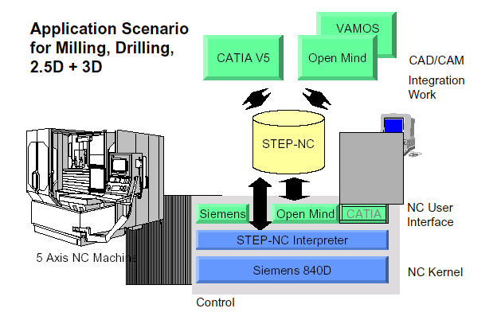
Figure 1 – Milling Demonstration at DaimlerChrysler
This project resulted in several test implementation of the ARM (ISO 14649 Parts 10, 11, and 111) A demonstration at DaimlerChrysler in mid-2000 showed a modified Siemens 840-D controller with a STEP-NC interpreter running on a Mikron 4-axis machine tool. This was provided data by STEP-NC export extensions built into CATIA v5 and Openmind/VAMOS. These implementations showed the creation of machining features in the CAD system and tested the evaluation of STEP-NC workplans on a controller for a range of milling and drilling operations.
Additional validation has been performed by the National Research Lab for STEP-NC Technology (NRL-SNT) at the Pohang University of Science and Technology in Korea (POSTECH). They have implemented an intelligent control system that operates directly on STEP-NC data. This system includes shop floor planning, tool path generation, machine control, and an operation interface.
Figure 2 – NRL-SNT STEP-NC Environment
In the United States, both ARM and AIM validation have been performed by the Model Driven Intelligent Control of Manufacturing (MDICM) project. Refer to Section 5 for a complete description of this project.
Finally, the STEP-NC IMS project has recently begun (IMS project #97006), which will test both ARM and AIM models as well as advance the other technology-specific models (turning, EDM, etc) for international standardization. Countries participating from the European region are France, Germany, Italy, Sweden, and Switzerland; from the American region the United States; and from the Asian region, Korea.

Turning Model
The STEP-NC model for turning was developed at NRL-SNT of POSTECH in Korea and ISW of the University of Stuttgart in Germany. This type of machine removes material by moving a cutting tool into a spinning part. Turning parts are usually cylindrical and milling parts are usually prismatic. Part 12 of ISO 14649 describes turning process data and Part 121 describes turning tool parameters. Some of the recent milestones include:
- Preliminary work – User requirements for turning data model (Feb 2001)
Figure 3 – STEP-NC EDM Demonstration
- 1st Version of the turning data model (April 2001)
- Presentation at SC1 Frankfurt Meeting (May 2001)
- 2nd Version of the turning data model (May 2001)
- Presentation at SC4 San Francisco Meeting (June 12, 2001)
- 3rd Version of the turning data model (August E 2001)
- 4th and Harmonized version (September 10, 2001) presented at Fukuoka Meeting (Oct 2001)
- Publication as ISO standard in mid 2005.

EDM Model
The models for Wire and Sink EDM are being developed by AGIE-Charmilles , AMT, and École Polytechnique Fédérale de Lausanne (EPFL) in Switzerland. This type of machine is less common than milling or turning and uses an electric current to cut a part with very high precision. These models will become parts 13/1 and 13/2 of ISO 14649 and drafts are nearing readiness for CD ballot.
The Wire EDM model was validated by a test implementation produced under work package #6 of the ESPRIT STEP-NC project. The test implementation was demonstrated at AGIE-Charmilles S.A. in Geneva on December 12th, 2001. Figure 3 shows the data flow and components in the demonstration. The AlphaCAM system was modified to produce STEP-NC data with according to the EDM model. These workplans were then processed on two controller implementations. The first was a STEP-NC front-end that created AGIE Vision Code and communicating with an AGIE AGIECUT system. The second example was a native STEP-NC controller driving a Charmilles Technologies ROBOFIL 340 system.

Usage scenarios and usage tests
Figure 4 shows the current state of communication between design and manufacturing. Design creates the specification for a product using a CAD (Computer Aided Design) system. Detailing decides the manufacturing requirements for the product, also using a CADD (Computer Aided Design Draughting) system. Planning generates tools paths using a CAM (Computer Aided Manufacturing) system. And finally, manufacturing controls production using a CNC (Computerized Numerical Control) system.
When different systems are used, IGES files communicate 3D models from design to detailing, IGES and PDF files communicate drawing and 3D data to path planning and RS274D files communicate machining instructions to manufacturing.
Figure 4 – Current Practice in Design to Manufacturing Data Exchange
Data exchange can be inefficient. Therefore, in the some industries suppliers are required to purchase the same CAD/CAM systems as their customers. For example GM suppliers are required to purchase the GM CAD/CAM system, Ford suppliers are required to purchase a different Ford CAD/CAM system and so on. There are two drawbacks to this solution. First, the systems that can perform all the functions are very expensive. The second, more serious problem is that single systems do not extend into the manufacturing controller. Therefore, an old standard called RS274D is used to send part program data from the path planning system to the controller as a voluminous list of linear or circular tool motions that are hard to modify and severely limit the potential intelligence of the machine. This standard was an excellent idea in the 1970’s when the computer power of microprocessors was very limited, but less sensible now that most systems have the power to process 3D data.
STEP-NC defines a language for processing 3D data on the control, which is likely to change the way design and manufacturing data is processed. The new solution takes advantage of the increasing power of controllers and CAM systems to move the path planning function onto the controller. As a result the RS274D interface between path planning and the controller is either buried within the system, or eliminated by more tightly coupling the CAM system with the underlying functionality of the controller. Both of these usage models have been explored in the implementation tests for both ARM and AIM validation.
Figure 5 – CATIA with STEP-NC Test Part
Another new usage pattern is adding features to the data sent to manufacturing. In the demonstration at DaimlerChrysler, CATIA v5 adds these to the design and creates the manufacturing plan as shown in Figure 5. In the MDICM demonstrations described in the following sections, the feature information is added to AP-203 design data by a feature recognition system. A third possible source for feature information are systems that currently produce AP-224 data.

Integrated resources interpretation
The AIM mapping of the ISO 14649 documents began with an initial set of prototype mappings created in March 1999 (SC1/WG7/N156) under SC1 by Charles Gilman. Several revisions were done, but this was based on early drafts of the ISO 14649 models and was not completely harmonized with the other APs.
In early 2000 this work was moved under SC4 and taken over by David Loffredo and moved into SC4 as AP238. This work was based on the updated DIS ARM documents. The AIM mapping and harmonization with the existing application protocols and feedback to the ISO 14649 documents was done over the course of 2001 and the first months of 2002. The mappings were revised as needed until publication of ISO 14649 in 2004 and 2005. A complete revision history is included below.
AIM mapping and interpretation review sessions were held at the following
- "AP238 DIS Walkthrough," STEP Manufacturing WG3/T24. ISO TC184/SC4 Meeting, Seattle, WA, October 7, 2004.
- "AP238 Status," STEP Manufacturing WG3/T24. ISO TC184/SC4 Meeting, Bath, UK, July 6, 2004.
- "STEP-NC for Plate Cutting and Pipe Bending," Joint meeting, STEP Shipbuilding WG3/T23 and STEP Manufacturing WG3/T24. Seoul, Korea, November 7, 2002.
- "STEP-NC / AP-224 Turning Feature Comparison," ISO 14649-12 Ballot Comment Workshop, TC184/SC1 Meeting, Seoul, Korea, October 31, 2002.
- "Overview of Key STEP-NC Concepts," STEP-NC for Pipe Bending and Cutting Workshop. NIST, Gaithersburg, MD, May 9, 2002.
- "AP238 Walkthrough," STEP Manufacturing WG3/T24. Myrtle Beach, SC, ISO TC184/SC4 meeting, February 26, 2002.
- "AP238 Status and Walkthrough," STEP Manufacturing WG3/T24. Fukuoka Japan, ISO TC184/SC4 meeting, October 2, 2001.
- "AP238 Integrated Model," STEP Manufacturing WG3/T24. San Francisco, CA, ISO TC184/SC4 meeting, June 14, 2001.
- "STEP-NC: AIM Issues Discussion," STEP Manufacturing WG3/T24. Funchal ISO TC184/SC4 meeting, February 22, 2001.
- "Review of STEP-NC Integrated Data Model," STEP Manufacturing seminar hosted by ISO TC184/SC4/WG3/T19. Charleston ISO TC184/SC4 meeting, October 13, 2000.
- "Harmonization of STEP-NC Integrated Data Model," STEP Manufacturing seminar hosted by ISO TC184/SC4/WG3/T19. Bordeaux ISO TC184/SC4 meeting, June 28, 2000.
The AP238 AIM development also fed back issues to SC1 and ISO 14649. In particular, issues with the harmonization of feature concepts between ISO 14649, AP-224, and AP-214 were identified and fed back as ISO 14649 DIS ballot comments. This resulted in a number of changes to the ARM so that the feature descriptions are now harmonized.

AIM Document Change History
This describes the history of the AP238 AIM mappings and the changes between each of the document versions. Where the document was issued as an SC4 WG3 document, the N-number is noted.
Version 4.0, issued as wg3n2101 for IS publication (2006-06-11)
Preparing for IS publication. See the comment log for complete details on the resolutions to each of the DIS ballot comments. Updated all mappings and references to match the definitions in the final published ISO 14649 documents.
The tool mappings and AIM definitions have been updated to match the final Parts 10/111/121. In ISO 14649, the parameters from Tool_dimension and the Tool_body subtypes were revised and moved into the machining_tool hierarchy. Although the mapping tables needed to be revised, the underlying AIM representation, did not change much. Parameters are still in a machining_tool_body_representation related to the machining_tool. The type of tool is now given by the description of the machining_tool, rather than the name of the representation. The machining_tool_dimension_representation AIM instance was no longer needed and was eliminated. The machining_cutting_corner_representation AIM instance was added to handle the corner transition information added to Part 121.
Aded entries for all Application Objects to clause 4.2 so that it is easier to understand what AOs are present and where they come from. Where an AO is imported from ISO 14649, the entry in 4.2 is a normative reference to the defining document, plus an informative note with the ISO 14649 EXPRESS description and text directing the reader to the other document for the definition and usage.
Updating annex K to present annotated Part 21 descriptions for the ISO 14649 examples from parts 11 and 12, as well as new toolpath examples for CC1 and CC2.
Version 3.1, issued as wg3n1534 for DIS ballot (2004-10-29)
Harmonized GD&T Definitions
Added the application objects and associated mappings for the harmonized GD&T definitions. The application objects use the naming conventions established by Module 1050/AP-214, and I have added notes giving the equivalent AP-224 terminology for each. See the GD&T UOF listing for all 49 new objects.
In addition, the measure UOF has been reworked to merge the ISO14649 notion of toleranced lengths with the GD&T notion of toleranced measure values that can be lengths, angles, etc. Added several new base types for all measure values (value_with_unit, value_with_tolerance) and then redefined the ISO 14649 measure types so that they now have an explicit unit and, in most cases, can also have a tolerance qualification. This allows us to specify plus/minus, maximum, or minimum qualifiers to other process parameters (angles, times, speeds, etc.)
New AIM Subtypes for Relationships
Originally, all relationships were mapped as plain action_method_relationships with special strings in the name field. In Bath, at a special session hosted by WG12, an agreement was reached to add subtypes for action_method_relationships in the AP238 mappings to make the data clearer.
A survey of the mapping tables and EXPRESS rules identified 18 distinct relationships in the model. Some of them are used in more than one place. The relationships are listed in the following sections with the current string (and subtype if used), the objects that are pointed to by the relating and related attributes, and then the proposed new subtype.
The new action_method_relationship subtypes are shown below. Indenting is used to show some further subtyping.
machining_adaptive_control_relationship
machining_functions_relationship
machining_operation_relationship
machining_operator_instruction_relationship
machining_process_model_relationship
machining_strategy_relationship
machining_technology_relationship
machining_toolpath_sequence_relationship

machining_feature_relationship
machining_feature_sequence_relationship (and sequential_method)

machining_final_feature_relationship

machining_process_body_relationship
machining_process_sequence_relationship (and sequential_method)
machining_process_concurrent_relationship (and concurrent_action_method)
machining_process_branch_relationship
In addition, the following subtypes of product_definition_relationship are used:
machining_setup_workpiece_relationship
machining_project_workpiece_relationship

General Relationships
'operation'
ing machining_workingstep
ed machining_operation
==> machining_operation_relationship

'technology'
ing machining_operation
ing machining_toolpath
ed machining_technology
==> machining_technology_relationship

'machine functions'
ing machining_operation
ing machining_toolpath
ed machining_functions
==> machining_functions_relationship

'toolpath' and sequential_method
ing machining_operation
ing machining_approach_retract_strategy
ed machining_toolpath
==> machining_toolpath_sequence_relationship (sequential_method subtype)

'adaptive control'
ing machining_technology
ed machining_technology
==> machining_adaptive_control_relationship

'process model' and sequential_method
ing machining_functions
ed machining_process_model
==> machining_process_model_relationship (sequential_method subtype)

workpiece setup to instructions and sequential_method
ing machining_process_executable (is this right?)
ed machining_operator_instruction
==> machining_operator_instruction_relationship
Machining Strategies
The following three will be handled by the machining_strategy_relationship relation and the name will be used to distinguish between the different types of strategies. I expect that future ISO 14649 parts may introduce new types of strategies, so this allows us to integrate that in a consistent fashion.
'approach strategy'
ing milling_type_operation
ing turning_type_operation
ed machining_approach_retract_strategy
==> machining_strategy_relationship with name "approach"

'retract strategy'
ing milling_type_operation
ing turning_type_operation
ed machining_approach_retract_strategy
==> machining_strategy_relationship with name "retract"

'machining strategy'
ing drilling_type_operation
ing milling_type_operation
ing turning_type_operation
ing freeform_milling_operation
ed drilling_type_strategy
ed freeform_milling_strategy
ed milling_type_strategy
ed turning_type_strategy
==> machining_strategy_relationship with name "machining"
Executable Control Flow
The control-flow relationships between the executables (workplan, if/then, while, selective, parallel, and concurrent) will handled by machining_process_body_relationship and subtypes.
'workplan element' and sequential_method
ing machining_workplan
ed machining_process_executable
==> machining_process_sequence_relationship

'concurrent element' and concurrent_action_method
ing machining_process_executable (concurrent and parallel)
ed machining_process_executable
=> machining_process_concurrent_relationship

'body'
ing machining_process_executable (while)
ed machining_process_executable
=> machining_process_body_relationship

The following three branches will be handled by one subtype and the name will be used to distinguish between them in the true/false case.
'true branch'
ing machining_process_executable (if/then)
ed machining_process_executable
==> machining_process_branch_relationship with name "true branch"

'false branch'
ing machining_process_executable (if/then)
ed machining_process_executable
==> machining_process_branch_relationship with name "false branch"
'branch'
ing machining_process_executable (selective)
ed machining_process_executable
==> machining_process_branch_relationship
Features To Workingstep
Originally, the feature was on the ING side of the relationship and workingstep on the ED side. This was done based on the notion that the feature process executable behaved like a "workplan" collection of workingsteps for the feature. However, this caused confusion in practice, since the workingstep is already the ING side of the relation for operation, and there is a reasonable expectation for the feature relationship to behave in the same way. So, as part of this update, the sides of the relation are now as described below.
Also added a global rule called feature_optional_machining_process_property to document that a feature should have at most one process property with a name of "machining". It was unclear from the mapping table whether each workingstep/feature relationship used a separate process_property and feature_machining_executable for each or whether they were all collected through one.
'process feature' (also sequential method for turning)
ing machining_workingstep (previously was -ED)
ed machining_feature_process (previously was -ING)
==> machining_feature_relationship (for normal machining_workingsteps)
==> machining_feature_sequence_relationship (for turning workingsteps, this is a subtype of the plain feature_relationship and sequential_method because the turning workingstep has a list of features rather than just one)

'final feature'
ing machining_workingstep (previously was -ED)
ed machining_feature_process (previously was -ING)
==> machining_final_feature_relationship
Product Definition Relationships
'workpiece'
ing product_definition (project)
ed product_definition (workpiece)
==> machining_project_workpiece_relationship

'workpiece'
ing product_definition (setup)
ed product_definition (workpiece)
==> machining_setup_workpiece_relationship
The mappings have been updated as described, and the local constraints in the AIM subtypes have been updated for the new mappings. In order to document the constraints, the following EXPRESS functions were either added or modified
FUNCTION verify_optional_relating_amr (MODIFIED)
FUNCTION verify_optional_relating_amr_with_name (NEW)
FUNCTION verify_required_relating_amr (MODIFIED)
FUNCTION verify_required_relating_amr_with_name (NEW)
FUNCTION verify_related_type_for_amr (MODIFIED)
FUNCTION verify_related_type_for_amr_with_name (NEW)
FUNCTION get_count_of_relating_amr (NEW)
FUNCTION get_count_of_relating_amr_with_name (NEW)
Due to the new handling of related/relating in the relationships between feature and workingstep, the following EXPRESS functions were no longer used and were deleted:
FUNCTION get_related_amr
FUNCTION verify_required_related_amr
FUNCTION verify_relating_type_for_amr
Other Changes
Relaxed the type of the Toolpath_speed parameter from b_spline_curve to allow the more general bounded_curve. Updated mapping and machining_toolpath_speed_profile_representation where rules.
Added definition for nc_legacy_function capability along with restrictions in the definition to prohibit trivial/pathological use for things that can be done using the existing capabilities.
Added a tool holder profile attribute to the cutting_tool application object. This is defined as a surface of revolution and is required to for collision checking. Without it, the volume of space between the end of the tool flutes and the spindle was not defined.
Added maximum deviation parameters for cutter contact and cutter location trajectory toolpath application objects. These are necessary to permit controllers to make reasonable tradeoffs between accuracy and speed.
Added machine axis constraint description for limiting the solution space for axis motion on machines which might have multiple tool position solutions.
Added new AIM subtypes of product called machining_setup and machining_project. These replace the use of product category for Setup and Project. Constraints handled by the following global rules have been folded into the new subtypes as local rules and the globals have been eliminated.
RULE machining_project_requires_owner
RULE machining_project_requires_release_date
RULE machining_project_requires_workplan
RULE machining_setup_requires_security_plane
Changed machining_operator_instruction so that it is now a subtype of action_method_with_associated_documents. Updated the mapping for the document attribute to use the inherited set of documents rather than a document assignment.
Clarified the slot to slot_end mapping. The name attribute of feature_component_relationship must be either "course of travel start" or "course of travel end", but was not called out in the mappings.
The FDIS Part 111 definitions have changed dramatically between the v13 and v14 versions of the document. There is no longer a concept of a separate tool body object and all cutting_tool and component definitions have been removed from Part 10. This will require a change in all of the tool mappings but this has been deferred until an updated Part 121 is available that is compatible with the new Part 111.
Version 3.0, issued as wg3n1460 (2004-06-09)
Incorporated comments from NWI/CD ballot. Many editorial fixes and notes added, as well as more substantial changes described below. One of the more significant additions is the new "Fundamental concepts and assumptions" section which attempts to clarify the AIM representation of features and relationship to the ISO 14649 definitions. See 5.2.1 for more information.
Added support for the turning process data defined by ISO 14649-12 and 121. This results in three new mapping tables for the turning features, turning process data, and turning tools. The EXPRESS rules for some of the representation subtypes began to get lengthy, so I abstracted the common idioms into new "verify" functions. The following definitions are either new or have been updated to include new local rules for the turning model:
ENTITY contouring_turning_operation
ENTITY facing_turning_operation
ENTITY grooving_turning_operation
ENTITY knurling_turning_operation
ENTITY machining_dwell_time_representation
ENTITY machining_feed_speed_representation
ENTITY machining_functions (updated)
ENTITY machining_spindle_speed_representation
ENTITY machining_technology (updated)
ENTITY machining_tool (updated)
ENTITY machining_tool_body_representation (updated)
ENTITY machining_tool_dimension_representation (updated)
ENTITY machining_workingstep (updated)
ENTITY threading_turning_operation
ENTITY turning_type_operation
ENTITY turning_type_strategy
FUNCTION get_related_amr
FUNCTION verify_angle_measure_rep_item
FUNCTION verify_length_measure_rep_item
FUNCTION verify_linear_speed_measure_action_property
FUNCTION verify_linear_speed_measure_rep_item
FUNCTION verify_numeric_measure_action_property
FUNCTION verify_optional_rep_item
FUNCTION verify_pressure_measure_action_property
FUNCTION verify_pressure_measure_rep_item
FUNCTION verify_relating_type_for_amr
FUNCTION verify_rep_desc_for_action_property
FUNCTION verify_rep_type_for_action_property
FUNCTION verify_ratio_measure_rep_item
FUNCTION verify_required_related_amr
FUNCTION verify_required_rep_item
FUNCTION verify_rotary_speed_measure_action_property
FUNCTION verify_rotary_speed_measure_rep_item
FUNCTION verify_time_measure_rep_item
Added in additional ARM entities and the associated mappings to clarify the handling of approval data. The information requirements have been harmonized with the approval module (ISO 10303-1012).
Completed the mappings for all of the toolpath subtypes. For the toolpath its_type attribute we used the property name "movement type" rather than "trajectory type" to avoid confusion with the trajectory structure. Suggest the attribute be renamed in the ARM as well since we have two overlapping type notions: one from the structure (class hierarchy) and one from the attribute. Added local rules to the machining_toolpath and machining_toolpath_speed_profile_representation entities for the mappings.
Extended the mappings for transition features to allow both styles of relationships. Transition features as defined by ISO 14649-10 relate two features, but for compatibility with AP-224 and AP-214, transition features must also be allowed to relate two sets of faces. Relating two features is done in a way similar to compound feature. Corrected mappings for edge_round radius, first offset, and second offset that contained cut-and-paste errors from chamfer. Also, the ISO 14649 edge round is really equivalent to the AP-224 constant radius subtype of edge round, not the general case. Updated the mapping with the associated constraint on the shape_aspect description to bring this out.
Based on comments and discussions at the Seoul ISO, it became clear that the adaptive_control ARM concept was not a strategy, but rather, a type of machining technology. Deleted the subtype machining_adaptive_control_strategy (previously clause 5.2.3.1.46) and changed the mapping to go to a machining_technology instance with a description of "adaptive control". Also, based on those discussions, changed the machining_operator_instruction type to be a direct subtype of action_method rather than a subtype of machining process executable.
Added a new global rule restrict_unneeded_feature_usage which restricts the protrusion, marking, fillet, rib_top features that are present for compatibility with AP-224 until ISO 14649-10 or some other part requires them. A similar rule added to restrict the turning feature has been removed now that the turning model is present.
Changes That Affect Existing Applications Based on the CD version
When updating to the latest version of the AP238 specification, an existing CD application or data file will need the following changes in order to conform to the DIS. The following lists the ARM attribute and the change that was made in the AIM mapping tables.
FEEDS, SPEEDS, AND DWELLS
Updated mappings for the feedrate, spindle, cutspeed, and dwell attributes to be consistent across both milling and turning. These now call for a special representation and name/description strings. The pair of either/or attributes feedrate/feed_per_tooth on milling_technology used to be separate properties but have been merged into one, called "feedrate". The either/or has been moved down into the representation. The spindle/cutspeed attributes also now map to a single "spindle" property.
TECHNOLOGY.feedrate
Property name still "feedrate"
Uses machining_feed_speed_representation
rep and length measure both need names "feed speed"
MILLING_TECHNOLOGY.feedrate_per_tooth
Property name changed to "feedrate"
Uses machining_feed_speed_representation
rep and length measure both need names "feed per tooth"
MILLING_TECHNOLOGY.cutspeed
MILLING_TECHNOLOGY.spindle
Both now use property name "spindle"
Uses machining_spindle_speed_representation
For cutspeed rep name "cutting speed"
For cutspeed measure rep item name "surface speed"
For spindle rep name "spindle speed"
For spindle measure rep item name "rotational speed"
DRILLING_TYPE_OPERATION.dwell_time_bottom
Uses machining_dwell_time_representation
rep and time measure both need names "dwell time"
DRILLING_TYPE_OPERATION.feed_on_retract
Property name now "feedrate on retract"
Uses machining_feed_speed_representation
rep and ratio measure both need names "relative speed"
DRILLING_TYPE_STRATEGY.reduced_cut_at_start
DRILLING_TYPE_STRATEGY.reduced_cut_at_end
Uses machining_spindle_speed_representation
rep and ratio measure both need names "relative speed"
DRILLING_TYPE_STRATEGY.reduced_feed_at_start
DRILLING_TYPE_STRATEGY.reduced_feed_at_end
Property name now "reduced feedrate at start"
Property name now "reduced feedrate at end"
Uses machining_feed_speed_representation
rep and ratio measure both need names "relative speed"
MULTISTEP_DRILLING.dwell_time_step
Uses machining_dwell_time_representation
rep and time measure both need names "dwell time"
Changed the action_method description strings that indicate finishing or roughing operations. All operations now use "finishing" or "roughing". Previously, these were "finish milling" and "rough milling" but when adding the turning definitions were changed to a single set of strings consistant across all of the operations.
BOTTOM_AND_SIDE_FINISH_MILLING
BOTTOM_AND_SIDE_ROUGH_MILLING
PLANE_FINISH_MILLING
PLANE_ROUGH_MILLING
SIDE_FINISH_MILLING
SIDE_ROUGH_MILLING
action_method.description now "finishing" for finish
action_method.description now "roughing" for rough
The mapping for the tool dimension ARM concept has been changed to leave room for describing turning or other kinds of tools in the future. The machining_tool_dimension_representation AIM instance now requires representation.name = "milling". In the future, other kinds of tools will use a different name.
In mapping for TOOL_DIMENSION, the tool_top_angle was changed to tool_tip_half_angle. The attribute used to be called tool_top_angle, but was changed between DIS and FDIS versions of ISO 14649-111
TOOL_DIMENSION
representation.name must now be "milling" (previously, it was unspecified)
TOOL_DIMENSION.tool_top_angle/tool_tip_half_angle
angle measure name must now be "tool tip half angle" (attribute changed in 14649-111)
Corrected "if", "selective", and "while" mappings to use the name field of action_method_relationship like all other AMR mappings, rather than the description field. The sequential_method that relates an executable to a workplan now requires a name of "workplan element". Previously these did not require a name, but this change will distinguish them from sequential methods used for toolpaths and other relationships. Similarly, the mappings for "parallel" and "non-sequential" both call out a name of "concurrent element" for their entries.
IF_STATEMENT.true_branch
IF_STATEMENT.false_branch
action_method_relationship.name of "true branch" (previously used description att instead)
action_method_relationship.name of "false branch" (previously used description att instead)
SELECTIVE.its_elements
action_method_relationship.name of "branch" (previously used description att instead)
WHILE_STATEMENT.body
action_method_relationship.name of "body" (previously used description att instead)
WORKPLAN.its_elements
action_method_relationship.name of "workplan element" (previously unspecified)
NON_SEQUENTIAL.its_elements
PARALLEL.branches
action_method_relationship.name of "concurrent element" (previously unspecified)
As part of putting in the mapping for the new turning_workingstep concept, I realized that I had forgot to call out a description string to distinguish the existing mapping for machining_workingstep from that of the workingstep supertype concept (and then the new turning subtype). The mapping for machining_workingstep has been updated to call out an action_method.description = "machining", and the turning subtype calls out a description of "turning". This leave room in case other technology parts of ISO 14649 need to do similar things.
MACHINING_WORKINGSTEP
action_method.description must now be "machining" (previously unspecified)
Slightly changed the way that features are related to machining workingstep and the new turning workingstep. The feature describing the actual volume removed by the machining operation in this workingstep is called "process feature". In a machining_workingstep there is one, and it is required. It is also possible to relate a set of features with the workingstep to document features visible on the final part that the machining operation contributes to. These are related with the name "final feature". I have added an ARM definition for this to 4.2.
Also corrected EXPRESS rules for these relationships in machining_workingstep, which had reversed the -ED and -ING sides of the action method relationship from what was specified in the mapping tables.
MACHINING_WORKINGSTEP.its_feature
action_method_relationship.name of "process feature"
These relationships have changed to clear up confusion between process and final features. Now the its_feature attribute is always the thing machined (the process feature) and must always be present. It may appear that the "process" and "final" action method relationships have switched places, but in the current mapping you only look at the "process" one to machine. In the prior version, you needed to look at both to pick the right one.
MACHINING_WORKINGSTEP.final_features
action_method_relationship.name of "final feature"
New, a set of zero or more final part features. The "final" relationship is now only for tracability to the final design. Only the feature pointed to by the "process" relationship is machined.
Version 2.9 (in progress)
Incorporated some corrections to the EXPRESS definitions of the rules. In particular, changed the return types for all of the verify_* functions from BOOLEAN to LOGICAL. Incorporated feedback recieved at the TC184/SC4 Spring 2002 meeting in Myrtle Beach. In particular, Turning features are present for compatibility with AP-224, but the restrict_turning_feature_use rule has been added to temporarily restrict their usage until ISO 14649-12 is complete.
Added an index to conform with clause 4.1.3 and 4.3.3 of the supplementary directives and cleaned up some editorial things.
Version 2.8, issued as wg3n1089 (2002-02-24)
Huge update. Added all local rules for the AIM subtypes and global rules for the things that could not be described with local rules. Added descriptions of all of the new AIM entities, rules, functions in Section 5.2 (240+ pages!), the longform in Annex A (220+ pages!), and shortnames in Annex B. Types that originally appeared in AP-224 or AP-214 have been flagged with a note.
Changed the mapping path for material to property parameter. The previous version had material designation characterization refering to material_property rather than material_property_representation. Fixed some mappings that had related/relating instead of related_method/relating_method as attributes od action method relationships.
The mapping for general outside profile said that the shape aspect referring to outside_profile was named 'outside boundary', but it really should be 'boundary occurrance' to be consistant with the rest of the outside profile mappings and the shape profile mappings. I have corrected this in AP238, but it was transcribed from AP-224, so it should be corrected there too.
Added a new required description string of "milling" for machining_technology when used to represent a milling_technology ARM (which is the only type of technology currently defined by 14649). This was needed to make sure we could distinguish between the expected turning, edm and other types of technology settings. The "milling" description string is also required for machining_functions/ARM milling_machine_functions for the same reasons.
Changed the name of the action property for the through_pressure attribute of milling machine functions from "through pressure" to "through spindle pressure", which should be clearer and more symmetric with the on/off property.
Thread_drilling and tapping are now mapped to the same AIM object and distinguished by a description string. Since they were both internal thread forming operations, the distinction between them was just not large enough to have two different AIM objects.
Version 2.7 (2001-09-26)
Updated the listing of application objects in Clause 4 to reflect the latest documents.
Updated the mappings for the executable UOF to the latest ARM definitions. The ARM definitions for the boolean expressions have changed to be much more in line with the PLIB definitions. The way we do it in the AIM remains the same, but the mappings look a little different because the ARM structures have changed. Added a new representation subtype for offset vector and an action resource subtype for machining_cutting_component. Completed the mapping of cutting component. Added a new action method subtype for operator instructions found in the setup.
In the Part 11 ARM, the 2.5D milling strategies have changed a bit, which required changing the mappings for stepover direction from a direction to a descriptive rep item. Some NC functions have moved from Part 10 to Part 11, so they have moved around in the UOFs as well.
In the ARM defs for the 2.5D milling operations, the finishing allowance attributes have moved, so they are now documented in different places. Also, they are no longer described as "finishing allowance". Now they are just "allowance" for sides and bottoms, so we have dropped "finishing" from the action property names in the mapping. Some attributes on the drilling ARM defs also moved, so the properties for dwell time and feed on retract moved from the drilling strategy to the drilling operation, and overcut length was added to the more general milling machining operation type.
Each operation still has a machining strategy, which can be found in the AIM via an action method relationship named "machining strategy". But in the ARM, instead of describing the attribute once in the supertype, they now spread it out as a separate attribute in each subtype. Although the relationship is described in a different place, the AIM data does not change.
Version 2.6 (2001-09-18)
Added the mappings for all of the features and harmonized them with the AP-224e2 mappings. Added the surface texture mappings and harmonized with AP-214. Also added the value_range rep item type from AP-214 which makes it possible to represent values as ranges, which will be helpful when describing tool requirements.
Version 2.5 (2001-09-05)
Clarified the meaning of the rawpiece and bounding box attributes in a workpiece. Just remember that 1) the rawpiece is a separate product, and 2) the bounding box is the shape of the rawpiece product. The bounding box is the AP-224 "base shape" ARM notion, and the mappings now allow call out the AP-224 parameterized shape reps for the block and cylinder stock. (block_shape_representation and cylindrical_shape_representation)
Refined the way machining workingsteps relate to a feature. Added machining_feature_process subtype to link them. Previously this was a workplan, but that isn’t right because workplan has different semantics. Changed the relationship between them from a sequential_method to a more general AMR named "final feature". There will be another relationship for "in-process feature". Shortened the action.name from "feature machining operation" to just "machining".
Clarified the mapping for project so that it uses a product category to distinguish it from other workpiece products in the file. Changed the action.name from "main workplan" to just "machining" in order to match the property_process used with features. Also added the PDM attributes to project
Changed the mapping of Setup to be more similar to that of Project. This allows us to use the standard assembly method for relating each workpiece and its transforms. It is not technically an assembly, so we do not use NAUOs, only PDRs and then do the transforms with context dependant shape reps. The action method subtype previously used "machining_setup" has been eliminated. I think that the machining workpiece position subtype will also be eliminated, but I’m not quite there yet.
Clarified mapping for milling cutting tool. The action resource should refer to a action resource type with the value of "milling cutting tool". We need this to be able distinguish the milling tools from the other types of tools.
Changed the mapping for toleranced length measure. There are two ways to handle qualifications in Part 45. The measure_qualification is an auxiliary object that is associated with a measure with unit, while qualified representation item is a separate thing that is probably AND/OR combined with any rep item. Since the measure qualification is specifically intended for use with measures, we will use that. Previously, we had used qualified rep item. There is still a question over the use of limits and fits in the ARM model. This sort of thing is usually only in a dimensional callout, which we don't really have in this case.
Version 2.4 (dated 2001-07-25)
Added subtypes for the approach/retract and milling strategies. The subtypes for the plunge strategies have changed slightly, from a general "machining strategy" action method subtype to the more specific "machining approach retract strategy" subtype. All of the strategies and their attributes are present, which means that Part 11 is now completely mapped. Also corrected the mapping for the operation.its_tool_direction attribute.
Version 2.3 (dated 2001-07-16)
Completing mappings for the attributes of the Part 111 milling tool definitions.
Version 2.2 (dated 2001-07-12)
Completing mappings for the attributes of the Part 11 machining_operation subtypes.
Version 2.1 (dated 2001-07-05)
Milling process UOF mappings updated with new subtypes for all of the operations. The mapping to specific machining_operation subtypes is documented, including the correct entries for the description attributes. The mappings for all of the attributes are not yet complete though.
Version 2.0 (dated 2001-06-27)
Updated to resolve issues raised at Funchal about the handling of material, complex properties with multiple rep items, and control flow with PLIB expressions. Distributed with draft longform schema.
Version 1.0 (dated 2001-02-12)
First public distribution of the revised document, prior to the Funchal ISO meeting. All major Part 10 concepts mapped and subtypes available.

General Mapping Issues

Short form Use/Reference
The STEP convention for importing definition in the short forms is to USE specific entity definitions, USE entire AIC schemas, and REFERENCE functions from the IRs. I don’t understand the exact semantic reasons, but note the usage pattern.

Actions and Action Methods
The STEP-NC AIM makes heavy use of action methods to represent the process related parts of the model. The action schema in Part 41 defines action, action method, and action resource. In general, action describes a general goal, action method describes a specific way to achieve that goal, and action resource describes equipment used along the way.
Looking at AP-213 and 214, we see both actions and action_methods in use. AP-214 uses action to describe a hierarchic breakdown of a particular project. Action is used to describe the general goal -- such as machine this part. AP-213 and the STEP-NC AIM use action method for working steps because they describe a distinct means that has been chosen to reach that goal -- in this case machining with a specific tool in a specific place.
There may be many different ways to machine the part, many workplans, hence the action method. The concept remains the same though – make the part, hence the action.
In the STEP-NC AIM, action is used to relate the action methods to the products and shape aspects (features). Action resource is used to represent the tool requirements. The action methods and action resources can be further described by adding properties. Below is a high level diagram of the process definitions in the integrated resources:
Figure 6 – AIM Process Concepts
If you read through the IRs, you'll see a wide variety of supporting relationships and resources designed to describe aspects of the action methods in more detail. These tend to be missing from action because actions are more general conceptual things.
When associating actions to workpieces and features, we use the following entities.

property_product / property_product_association
process_product / process_product_association
Some APs use action_assignment from P41 to assign actions and use the derived role attribute added by the second edition IRs to distinguish them. We use the property/process_product approach because they it is designed specifically for our case and simpler than action_assignment. We may use the assignment in future versions if we should need to associate an action_method to something that doesn't work with the PP framework.

Subtypes and Naming Conventions
When creating AIM subtypes, the primary concern is whether it helps the end user to understand things. A secondary concern is whether it helps us to document constraints as local rules rather than global rules. In general, I only create subtypes for new concepts. If a concept already exists in another AP, I have adopted the subtypes defined by those APs. An example of new concepts would be machining workingstep. An example of existing concepts would be the features in AP-224/214.
When creating subtypes, I have been trying to prefix everything with “machining_”. This works well for the general Part 10 process things, but going into the Part 11 operations, it becomes more difficult to maintain. With the Part 11 things, I have tried to maintain some sort of consistency, even if a prefix was not appropriate.

Subtypes of Relationships
Originally, all relationships were mapped as plain action_method_relationships with special strings in the description field. In Bath, at a special session hosted by WG12, we agreed to add subtypes for action_method_relationships in the AP238 mappings to make the data clearer.
Going through the mapping tables and EXPRESS rules produced 18 distinct relationship. Some are used in more than one place. The new action_method_relationship subtypes are shown below. I have used indenting to show some further subtyping.

machining_adaptive_control_relationship
machining_functions_relationship
machining_operation_relationship
machining_operator_instruction_relationship
machining_process_model_relationship
machining_strategy_relationship
machining_technology_relationship
machining_toolpath_sequence_relationship

machining_feature_relationship
machining_feature_sequence_relationship (and sequential_method)

machining_final_feature_relationship

machining_process_body_relationship
machining_process_sequence_relationship (and sequential_method)
machining_process_concurrent_relationship (and concurrent_action_method)
machining_process_branch_relationship
In addition, the following subtypes of product_definition_relationship are used:

machining_setup_workpiece_relationship
machining_project_workpiece_relationship

String Values
When mapping ARM attribute names with underscores into string values for properties, do we keep the underscores or remove them? AP-224, AP-214 and others seem to replace the underscores with a space, but I’d like to find a citation somewhere that states this as the policy. AP-209 on the other hand uses underscores in their strings. I follow the AP-214/224 convention and use whitespace.
Need to be careful about the naming of properties, since it is not always the same as the attribute name. In some cases, the string value changes, like feature placement becomes ‘orientation’ to match with AP-224. Presumably, this is done in 224 to be compatible with someone else (214?).
I have been checking against AP-224, AP-214, and AP-209 to make sure that we use the name conventions for the properties.

Properties and their Representation
Since STEP-NC is all about process description, we make heavy use of action properties. The question is whether to map one property per ARM attribute, or to somehow group several ARM attributes into a single representation?
In general, I map each attribute of the major ARM concepts to a separate property. This is the most flexible way of handling the attributes because future mapping may allow for different representations. Today, the mapping usually calls out a numeric representation, such as a length or angle measure. One specific advantage of this approach is that future versions easily replace a single numeric representation with one containing an expression or range of values. This also avoids problems with conflicting representation contexts and is consistent with the way validation props are represented.
If an ARM object is not a major concept, just a complex single property, it will be mapped to representation. The type of ARM object will be distinguished by the representations description field or by a representation subtype, and then multiple rep items within it will be distinguished by name. This is useful if the entire complex property might be described in a different way by a different representation.
A good example of this is the bounding-box description of stock used by both AP-224 and 238. The bounding box is normally described by a shape_rep_with_parameters with a length, width, and height measure rep item in it. Those three values are contained within a single representation because they are describing aspects of a single conceptual property. This same complex property could be described by any other shape representation, such as a manifold brep shape representation.
Regardless of whether a property is simple or complex, it is related to an action method using the following reference path. It distinguishes the property from others using the action_property name attribute. It has a representation that contains one or more specific types of rep item. If there is more than one rep item, they have names.

ACTION METHOD SUBTYPE <=
action_method
characterized_action_definition = action_method
characterized_action_definition <-
action_property.definition
{ action_property.name = ‘PROPERTY NAME’ }
action_property <-
action_property_representation.property
action_property_representation
action_property_representation.representation ->
representation
representation.items[i] ->
representation_item =>
REPRESENTATION ITEM SUBTYPE

Also, note that the new part 43 has a value rep item that is like a measure rep item, but without the unit. It assumes the global unit. We have not used this in any of the mappings, but it might be an interesting thing to consider for some values. Obviously, it can’t really be used for things that don’t have an unambiguous measure_value thing associated with it, like pressure or velocity (see below).

Measures, Units, and Tolerances
Below is an ARM fragment that I am considering for AP238. As written, the ISO 14649 spec does not have units. It also defines plus/minus and limits/fits tolerances for length parameters, but nothing else.
In the AP238 ARM, we must extend the ISO 14649 model to document that values have units and to allow tolerance qualifications for the other types of parameters. These tolerance qualifications are used for geometric dimensions as well.
The model below combines limit, plus/minus, and L/F into value_with_tolerance. This is similar to the AP-224 ARM object “Numeric parameter with tolerance.” The qualifier is optional, so it can default to a nominal value. This makes the model cleaner and matches the way ISO 14649 modeled toleranced_length_measure.
Geometric_dimension.value would be a value_with_tolerance or value_range. Note that only geometric dimensions may have a range, the feature and process parameters only have a single value w/tolerance.
The ISO 14649 measure types are redefined as subtypes of either value with unit or value with tolerance as shown below. Each subtype constrains the value component to be of the appropriate measure type (length, angle, time, etc.), but makes no other additions.
ISO 14649 length_measure ➔ value_with_unit, value component is a length
ISO 14649 toleranced_length_measure ➔ value_with_tolerance, value is a length
ISO 14649 time_measure ➔ value_with_tolerance, value component is a time
ISO 14649 plane_angle_measure➔ value_with_tolerance, value component is an angle
ISO 14649 pressure_measure ➔ value_with_tolerance, value component is a numeric
ISO 14649 speed_measure➔ value_with_tolerance, value component is a numeric
ISO 14649 rot_speed_measure➔ value_with_tolerance, value component is a numeric
The ARM model is as follows:

ENTITY value_with_unit;
unit : unit;
value_component : measure_value;
END_ENTITY;

ENTITY value_with_tolerance;
SUBTYPE OF (value_with_unit);
limitation : OPTIONAL limitation_select;
significant_digits : OPTIONAL INTEGER;
END_ENTITY;

ENTITY value_range;
lower_range : value_with_unit;
upper_range : value_with_unit;
significant_digits : INTEGER;
END_ENTITY;

TYPE limit_qualifier = ENUMERATION OF (maximum, minimum)
END_TYPE;

TYPE limitation_select = SELECT (
limit_qualifier,
plus_minus_bounds,
limits_and_fits
);
END_TYPE

ENTITY plus_minus_bounds;
lower_bound : measure_value;
upper_bound : measure_value;
END_ENTITY;

ENTITY limits_and_fits;
deviation : STRING;
fitting_type : OPTIONAL STRING;
grade : STRING;
END_ENTITY;

ENTITY length_measure
SUBTYPE OF (value_with_unit);
END_ENTITY;

ENTITY toleranced_length_measure
SUBTYPE OF (value_with_tolerance);
END_ENTITY;

ENTITY time_measure
SUBTYPE OF (value_with_tolerance);
END_ENTITY;

ENTITY plane_angle_measure
SUBTYPE OF (value_with_tolerance);
END_ENTITY;

ENTITY pressure_measure
SUBTYPE OF (value_with_tolerance);
END_ENTITY;

ENTITY speed_measure
SUBTYPE OF (value_with_tolerance);
END_ENTITY;

ENTITY rot_speed_measure
SUBTYPE OF (value_with_tolerance);
END_ENTITY;
In the AIM, each of these values will be mapped to a measure_representation_item. This allows us to associate the value to a property by placing it the items attribute of a representation instance. The measure_representation_item type inherits from both measure_with_unit and representation_item. When the measurement requires a subtype of measure_with_unit, such as for a length or plane angle, the entire thing must be a complex instance of that subtype with measure_representation_item.

Pressure and Speed measures
Pressure and linear/rotational speed measures are mapped as plain measure rep items, because there are no specific subtypes for them. Within the measure representation item, the measure_value select should contain a numeric_measure.
In AP-227, pressure may be mapped as a ratio_measure with a derived unit (presumably weight/area). I don’t know if that sort of mapping choice makes sense in the general case because once you get beyond the fundamental quantities, everything is a ratio of something to something else. In AP238, I have used ratio for things like fractional multipliers (such as the relative speed/feed parameters described in the following section) but numeric measure for all of the other “subtype-less” measures.

Spindle, Feed, and Dwell measures
A large number of properties in AP238 talk about feedrates, spindle speeds, or dwell times. In addition, there are several different ways to describe each of these measurements. For example, a feedrate could be described either as a velocity, or as a length per tooth of the tool being used. Conceptually, these are describing the same thing, but using different representation techniques.
In the AIM, we encode this using a single property for the concept “feedrate” which we associate with a subtype of representation that can describe the feedrate using any of the different techniques. The new representation subtypes are:

machining_feed_speed_representation
machining_dwell_time_representation
machining_spindle_speed_representation
The feed speed representation handles what appears to be four different ways of describing a feedrate:
- linear speed, as described by the ARM definitions for the Technology "feedrate" attribute in ISO 14649-10 and Feed_velocity_type in ISO 14649-12;
- length per tooth of a tool, as described by the ARM definition for the Milling_technology "feedrate_per_tooth" attribute in ISO 14649-11;
- length per spindle revolution, as described by the ARM definitions for the Turning_technology "feedrate_per_revolution" attribute and Feed_per_rev_type in ISO 14649-12;
- relative speed, expressed as a multiplier applied to a separate feed speed, as described by ARM definitions for the Drilling_type_strategy "reduced_feed_at_start", "reduced_feed_at_end", and Drilling_type_operation "feed_on_retract" attributes in ISO 14649-11, as well as definitions for the Turning_machining_strategy "variable_feedrate" and Contour_turning "variable_stepover_-feed" attributes in ISO 14649-12.
The spindle speed representation handles what appears to be three different ways of describing a spindle speed:
- rotational speed, as described by the ARM definitions for the Milling_technology "spindle" attribute in ISO 14649-11 and Const_spindle_speed in ISO 14649-12;
- linear speed measured at the contact point between tool and surface, as described by the ARM definition for Milling_technology "cutspeed" attribute in ISO 14649-11 and Const_cutting_speed in ISO 14649-12;
- relative speed, expressed as a multiplier applied to a separate spindle speed, as described by the ARM definitions for the Drilling_type_strategy "reduced_cut_at_start" and "reduced_feed_at_-end" attributes in ISO 14649-11.
The dwell time representation handles what appears to be two different ways of describing a dwell time:
- time measure, as described by the ARM definitions for the Feedstop "dwell" attribute in ISO 14649-10, the Multistep_drilling "dwell_time_step" and Drilling_type_operation "dwell_time_-bottom" attributes in ISO 14649-11, and Dwell_time in ISO 14649-12;
- count of spindle revolutions, as described by the ARM definitions for Dwell_revolution in ISO 14649-12.
The different ISO 14649 ARM documents use different modeling styles to put these alternatives into the ARM. The milling document (Part 11) uses different attributes for each option and then adds a local rule forbidding the use of more than one at a time, for example Milling_technology “spindle” and “cutspeed”. The turning document (Part 12) uses a SELECT type to model the options, for example Speed_select. In the AIM, all of our examples would map to a single “spindle” property that would be associated with a machining_spindle_speed_representation. Looking at this representation would tell you which technique (rotary spindle speed or linear cutting speed) would be used.
The representation tells you which technique is being used by using a special string value for the representation “description” attribute. Within it are measure representation items that give the numeric values. The allowable combination are described by the local rules on the EXPRESS definition. For example, look at the feed representation:

ENTITY machining_feed_speed_representation
SUBTYPE OF (representation);
WHERE
WR1: (SELF.name IN ['feed speed', 'feed per revolution',
'feed per tooth', 'relative speed']);

WR2: NOT (SELF.name = 'feed speed') OR
(verify_required_rep_item (SELF, 'feed speed') AND
verify_linear_speed_measure_rep_item (SELF, 'feed speed')
);

WR3: NOT (SELF.name = 'feed per revolution') OR
(verify_required_rep_item (SELF, 'feed per revolution') AND
verify_length_measure_rep_item (SELF, 'feed per revolution')
);

WR4: NOT (SELF.name = 'feed per tooth') OR
(verify_required_rep_item (SELF, 'feed per tooth') AND
verify_length_measure_rep_item (SELF, 'feed per tooth')
);

WR5: NOT (SELF.name = 'relative speed') OR
(verify_required_rep_item (SELF, 'relative speed') AND
verify_ratio_measure_rep_item (SELF, 'relative speed')
);
END_ENTITY;
Based on the value of the name attribute, the representation should contain representation items as follows:
- when the name is “feed speed”, it must contain a measure_representation_item, also with a name of “feed speed” that gives the linear feed velocity (for example 2 mm/s ).
- when the name is “feed per revolution” it must contain a length_measure_with_unit + measure_representation_item, also with a name of “feed per revolution” that gives the length per spindle turn (for example 1 mm)
- when the name is “feed per tooth”, it must contain a length_measure_with_unit + measure_representation_item, also with a name of “feed per tooth” that gives the length per tooth of the tool used (for example 1 mm)
- when the name is “relative speed”, it must contain a ratio_measure_with_unit + measure_representation_item, also with a name of “relative speed” that gives the constant to multiply another feedrate by (for example 0.8 for 80% of the feed)
Not all of these combinations are allowed in every case. The mapping tables will list the particular ones that can be used for an ARM attribute. For example, the Drilling_type_-operation "feed_on_retract" attribute can only be specified as a ratio, so the mapping calls out the “relative speed” name for the represenation.

Shape Representations
In addition to all of the shape reps defined by the various shape AICs, we use the shape rep with parameters type . This was adopted from AP-224 see section 5.2.3.1.72 of AP224 and 5.2.3.1.135 of AP214. Rules there restrict the rep items to placements, measures with units or descriptive rep items.
A shape_representation_with_parameters is a kind of shape_representation in which the shape of a product_definition or shape_aspect is defined implicitly using measurements and descriptive parameters. EXAMPLE - The shape of a box may be specified by a shape_representation_with_parameters by giving measurements for its height, length, and width.

Expressions and Properties
The control flow elements of a workplan reference a controlling expression. How is this represented in the AIM? We will use the PLIB expression schema (ISO 13584-20) which is also being incorporated into the new Part 50 Integrated Resource. But these parts define a separate hierarchy of expression definitions. How do we use those in a conventional STEP property representation?
We can gain insight by looking at how measure_with_unit is used. Whenever we use a length or plane angle measure in a representation, we create a complex instance of the appropriate measure type and “measure_representation_item”. Here, we will do the same thing with expressions. First, we will create a new entity that multiply inherits from rep item and the root of all expression types “generic_expression”

ENTITY expression_representation_item
SUBTYPE OF (representation_item, generic_expression);
END_ENTITY;
Then, in order to refer to an expression, we will create a complex instance of the appropriate subtype, like boolean_expression, with expression_rep_item. This will let us convey the boolean_expression in a normal STEP representation
Figure 7 – Using PLIB Expressions in Representations

Just to note, AP-214 also references the PLIB expression schema to model units with an explicit expression. They create something called expression_conversion_based_unit that is related to variable_semantics. There are types for each unit, so that they can be used in an expression, expression_conversion_based_unit is the main, but this refers to an expression through an environment, with the other variables using derived_unit_variable, named_unit_variable,

AIM validation
The AP238 AIM models was validated in the USA by the Model Driven Intelligent Control of Manufacturing project (MDICM), a three-year Advanced Technology Project that was awarded to STEP Tools by the NIST in November 1999. This project has an Industrial Review Board (IRB) consisting of Fortune 500 companies, software developers of CAD and CAM products, machine tool manufacturers, job shops and industry experts and consultants. A list of the members is shown below.

Alibre, Inc. | ARC Advisory Group | Benet Laboratories
CADKEY Corp. | Cambridge Valley Machining Inc. | CamSoft Corporation
Caterpillar | CIMPlus | Cincinnati Machine
CNC Software (Mastercam) | DaimlerChrysler | Dutchess Precision Industries
Electro-Mechanical Integrators, Inc. | ESPRIT CAM by DP Technology | Fala Technologies
Ford Motor Company | General Dynamics Land Systems | General Electric Fanuc
General Electric Power Systems | General Electric R&D | General Motors Powertrain
Gibbs and Associates (GibbsCAM) | Honeywell FM&T | Hurco Companies, Inc.
IBM Corporation | IBM Software | Ingersoll International Inc.
Jet Propulsion Laboratory | Lawrence Livermore National Laboratory | Liberty Consulting
Litton - Avondale Industries | Lockheed Martin Tactical Aircraft Systems | LoDolce Manufacturing
Louisiana Center for Manufacturing Sciences | ManufacturingQuote, Inc. | Maverick Precision Manufacturing of Canada
MDSI | NASA/GSFC | National Center for Manufacturing Sciences
National Institute of Standards and Technology (NIST) | Northrup Grumman | Otto-Tech Machine Company, Inc.
PCAM Solutions | Pratt & Whitney | PTC
RCM and Associates | Rensselaer Polytechnic Institute, Center for Automation Technologies | Supplier Based Manufacturing Management (SBMM)
The Boeing Company | The Design Edge | The Shaw Group
U.S. Army | Unigraphics Solutions e-Factory
Table 1 – MDICM Project IRB Members
The MDICM project validated the AIM with test implementations and held five internal demonstrations since December of 1999. Now IRB members are running demonstrations using their own parts and machines.

AP238 CC3 Milling Testing at General Dynamics Land Systems (GDLS) August 2001
The first such demonstration was organized by General Dynamics Land Systems (GDLS) and held in August 2001. They hosted it at their tank components manufacturing plant in Scranton, Pennsylvania. The demonstration featured a STEP-NC Controller built by loading an MDSI controller onto a PC running the Windows NT operating system and connected to a 3-axis Bridgeport Machine. A STEP-NC compiler and Virtual Gibbs CAM software were also loaded onto the PC as shown in Figure 12.
In a live demonstration to GDLS management, the STEP-NC interpreter was used to read previously prepared AP238 data. Each operation in the data was translated into a Virtual Gibbs command by the STEP-NC compiler and used to create a fully defined manufacturing database in the Virtual Gibbs environment. The GibbsCAM software then generated the tool paths necessary to make the part and posted the required codes to the MDSI software. This was done without significant operator intervention. The STEP-NC Controller contained a lot of software, but like an automobile, putting more electronics under the “hood” made the controller easier to use not harder. With the STEP-NC compiler, the operator only had to choose between three commands:
- Run. Meaning read and fully execute all the STEP-NC working steps in the AP238 file and post the result to the MDSI controller for immediate execution.
- Verify. Meaning read and execute the STEP-NC working step data, populate the Virtual Gibbs software and use that software to check for collisions or other manufacturing problems.
- Document. Meaning read and execute the STEP-NC commands but this time use the Virtual Gibbs software to create a spreadsheet describing the part before and after each operation.
Under the ‘hood”, the GDLS STEP-NC Controller allows more detailed monitoring and modifying of the process using GibbsCAM and the underlying MDSI controller. To demonstrate speed and flexibility, the GDLS team showed two live scenarios to its management and one scenario by video link. The first live scenario showed an operator using GibbsCAM to create the manufacturing process from AP-203 (STEP) data in about 45 minutes of pre-rehearsed effort. The second scenario showed the GibbsCAM database being created instantaneously and automatically from AP238 data and being posted to the MDSI control without any operator intervention. The video link scenario used an advanced Open Modular Architecture Controller (OMAC) designed and developed by General Motors and Lawrence Livermore National Laboratories and hosted by the Louisiana Center for Manufacturing Sciences (LCMS) in Shreveport, Louisiana. The OMAC defines how to divide a controller into modules and has the potential to make STEP-NC Controllers even more flexible by allowing sensor based controls to be linked to STEP-NC data enabling truly intelligent machining.
Figure 12 – General Dynamics STEP-NC Controller
Figure 12 shows the architecture of the controller used in the demonstration. In this figure the AP238 plug-in is the STEP-NC compiler. It is called a plug-in here because it was implemented as a library that plugs into the GibbsCAM environment. The architecture shown in Figure 12 is only a first cut at implementing STEP-NC on a controller. In the future dynamic compilers can be expected to take advantage of feedback from sensors to optimize performance.
In the GDLS demonstration the AP238 plug-in could read STEP Part 21 data directly, or it could read XML data from a web server. Both formats were able to convey all of the necessary information, but the XML format contained many redundancies so it should not be used for data archiving. On the other hand, XML is more compatible with Internet protocols so applications that want to implement advanced functionality usually prefer it to Part 21.
As mentioned in previous sections, An international Intelligent Manufacturing Systems (IMS) STEP-NC project has recently begun (IMS project #97006), which will further validate the AIM model as well as perform some interoperability testing between implementations. Participating from the European region are France, Germany, Italy, Sweden, and Switzerland; from the American region the United States; and from the Asian region, Korea.

AP238 CC3 Multi-Axis Milling Testing at NASA Jet Propulsion Lab, January 2003
The 6th Industrial Review Board (IRB) Meeting was hosted by NASA Jet Propulsion Laboratory (JPL) in Pasadena, CA, on January 29-30, 2003. STEP Tools worked with JPL to demonstrate the machining of a part using full fidelity STEP-NC product data as direct input to a multi-axis CNC milling machine. The machine was a FADAL VMC with a 32MP controller, 486 processor, running Windows 95 operating system
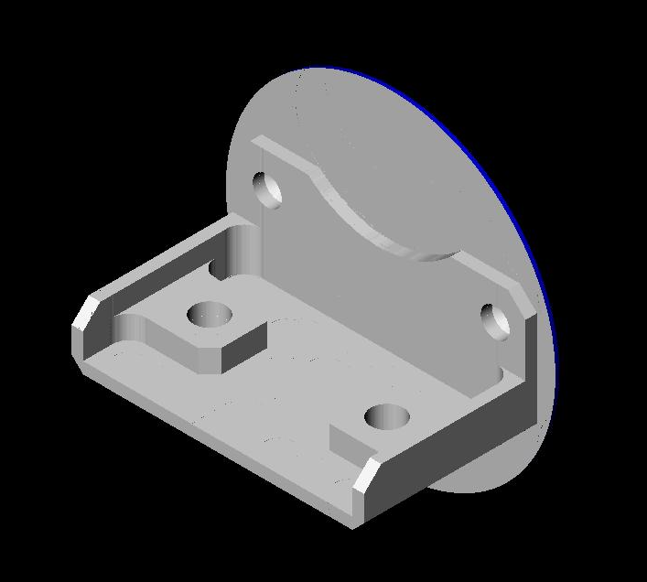
Figure 13 – Test Part for Multi-Axis Demonstration

This demonstration exercised the use of AP238 CC3 feature-based programming using feature recognition technology provided by Honeywell to rapidly convert AP-203 (STEP) models into AP238 (STEP-NC) CNC-independent control data with tolerances using JPL crib sheets, and presented an automated set-up wizard for defining setup and fixtures.
The results were very favorable, when compared to manual programming of the job. Program time dropped from 105min to 12 min and setup time remained constant. The machining run-time of the job increased slightly from 16.5min to 23min, which showed room for optimization in the toolpaths generated from the manufacturing features.
This demonstration showed the ultimate goal of STEP-NC, serving as direct input to a CNC machine tool, thus eliminating post processors, G & M codes, data redundancy, multiple CAD files, and more. Availability of featurized data remains an issue with the use of CC3 feature-based programming, as automatic recognition techniques have limits when presented with interacting features and parts that lack obvious 2.5D features.

AP238 CC1 Testing for 5-Axis Machining, February 2005
On February 3rd, 2005 the OMAC STEP-NC Working Group hosted an AP238 testing forum in Orlando Florida. The tests were done on 5-axis parts using AP238 CC1 machine independent toolpaths.
Four CAD/CAM systems produced AP238 machining programs for milling a 5-Axis test part (an NAS 979 circle/diamond/square with an inverted NAS 979 cone test in the center). Each of these was then run on a pair of CNCs configured for completely different machine geometries (AB tool tilt vs. BC table tilt).
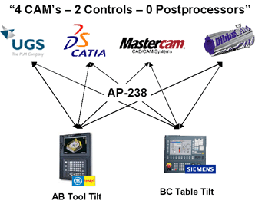
Figure 14 – CC1 5-Axis Testing Scenario
In addition to the activities in Florida, Boeing cut actual parts on a variety of machines at the Tulsa facility as well as a machine at NIST in Gaithersburg.
../Users/alvares/Downloads/2005_orlando/ap238_5axis_tests.jpg Figure 15 shows two of the machined circle/diamond/square and sample aerospace parts produced during the tests. The walls of the sample aerospace part may look vertical but actually have subtle 1-2 degree inclinations that require 5-axis machining. In addition there are several holes in the walls that must be drilled at odd angles.
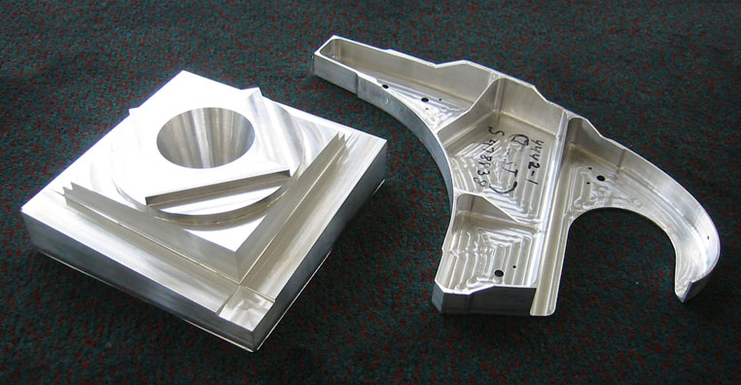
Figure 15 – CC1 5-Axis Test Parts
The demonstrations showed that AP238 CC1 AIM data file sizes and processing times were well behaved and comparable to other tool path description forms. For the NAS 979 CDS/Cone test part, a CATIA CL file required 201 KB, but an AP238 file was only 114 KB. The Siemens and Fanuc G-Code descriptions of the same tool paths required 45 KB to 104KB. Total processing time for the file was 5 seconds on a 1 GHZ Pentium.
For the 5-axis aerospace part, a CATIA CL file size required 2077 KB, the AP238 file required 2305 KB, and the G-codes 560 KB to 1304 KB. Total processing time was 20 seconds.

AP238 CC2 Testing for Closed Loop Machining, May 2005
On May 24-26, 2005, the OMAC STEP-NC Working Group held an AP238 testing forum event at EASTEC 2005 in Springfield, MA. Representatives from Boeing, Unigraphics, NIST, Pratt and Whitney, and STEP Tools were present and Siemens graciously provided space in their booth.
This event focused on demonstrating AP238 CC2 closed-loop machining using touch trigger probes and cutter contact machining driven from STEP-NC. The scenario was to rough and finish a boss on an engine casing test part provided by Pratt and Whitney. After roughing and semi-finishing, a probing operation is used to adjust a final finising pass. The finishing is done using cutter contact paths. To further test interoperability, the roughing paths are created by one CAM system and the finishing paths by another. The complete scenario was as follows:
- Stage 0: Export Part model from UGS NX
- Stage 1: Roughing operation from UGS NX
- Stage 2: Probing operation from Mastercam
- Stage 3: Probing results from DMG
- Stage 4: CNC Tool diameter compensation
- Stage 5: Finish operation from Mastercam
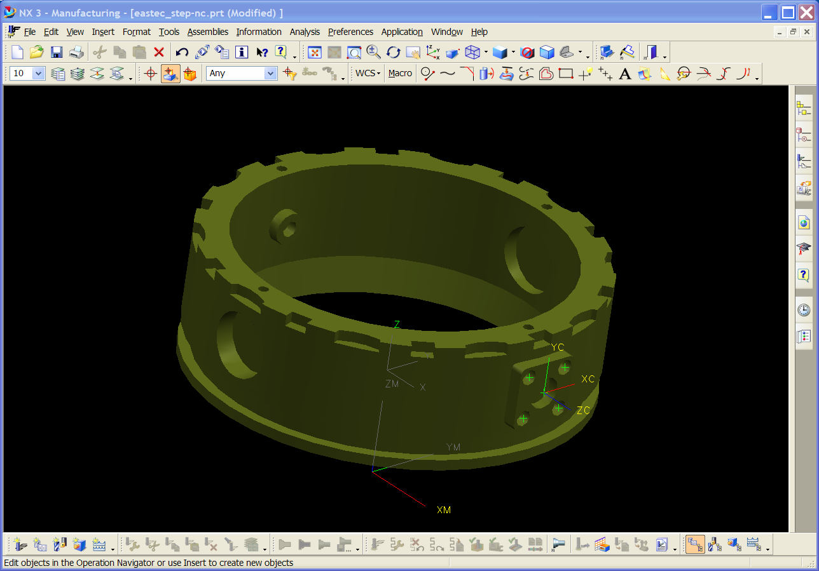
Figure 16 – Engine Casing Test Part

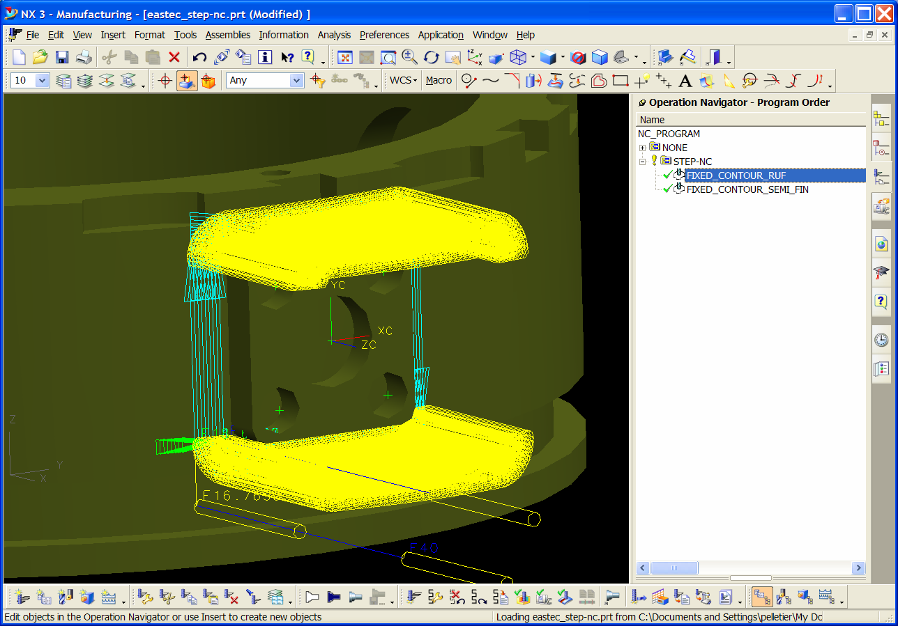
Figure 17 – Roughing Tool Paths in UGNX

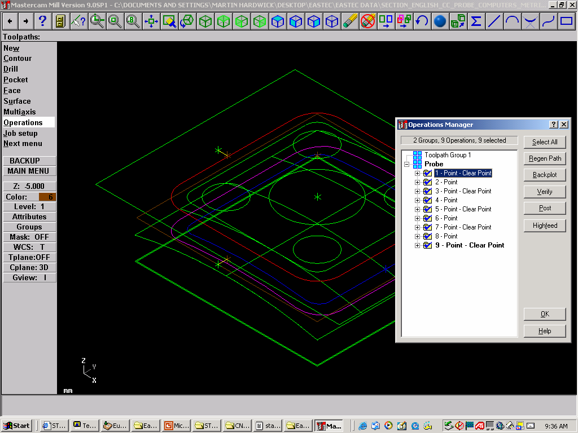
Figure 18 – Probing Tool Paths in Mastercam
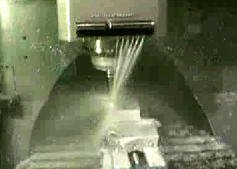
Figure 19 – Roughing and Probing on NIST DMG

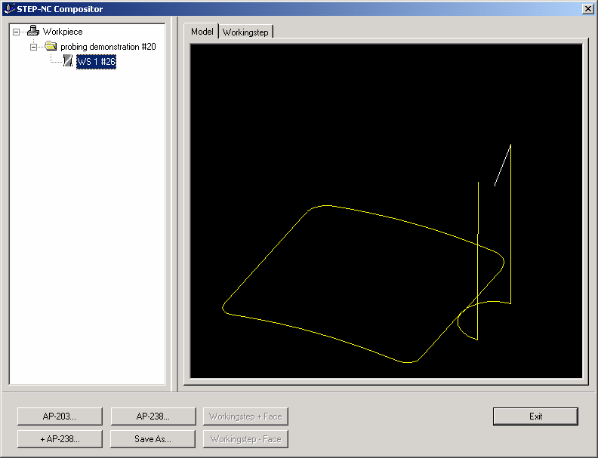
Figure 19 – Finishing Cutter-Contact Tool Path

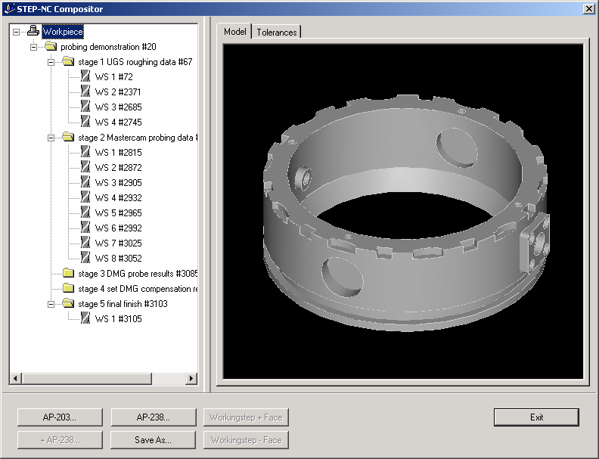
Figure 20 – Final Closed-Loop Program

AP238 Aerospace Demonstration, Toulouse June 2006
In October 2005 in Beijing, China, ISO TC184/SC 1 and SC 4 members met jointly and decided to foster STEP-NC implementations through three demonstrations to be organized in 2006: the first in Busan, Korea, at the beginning of May 2006, the second in Toulouse, France at the end of June dedicated to the Aerospace industry, the third at the end of October in Hershey, USA dedicated to Automotive industry.
The demonstration in Toulouse was held on 2006-06-28 at the Université Paul Sabatier Laboratoire de Génie mécanique and consisted of a live demonstration of 5-axis milling of Aerospace test parts provided by Airbus. In addition, a previous machining done in Boeing’s plant was displayed.
The demonstration showed the use of AP238 to integrate manufacturing data from many sources. The scenario used feature-based machining to automatically generate the roughing operations on the workpiece and then used explicit 5-axis tool paths for the finishing of the part. The data flow in the demonstration is shown in Figure 21.

Figure 21 – Toulouse Demonstration Scenario
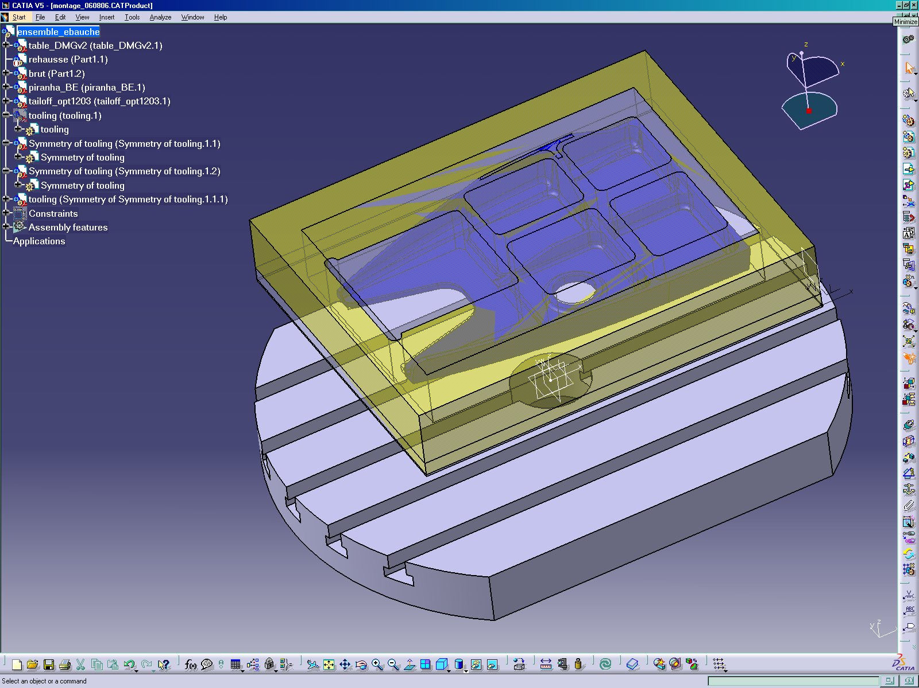
Figure 22 – Aerospace Test Part

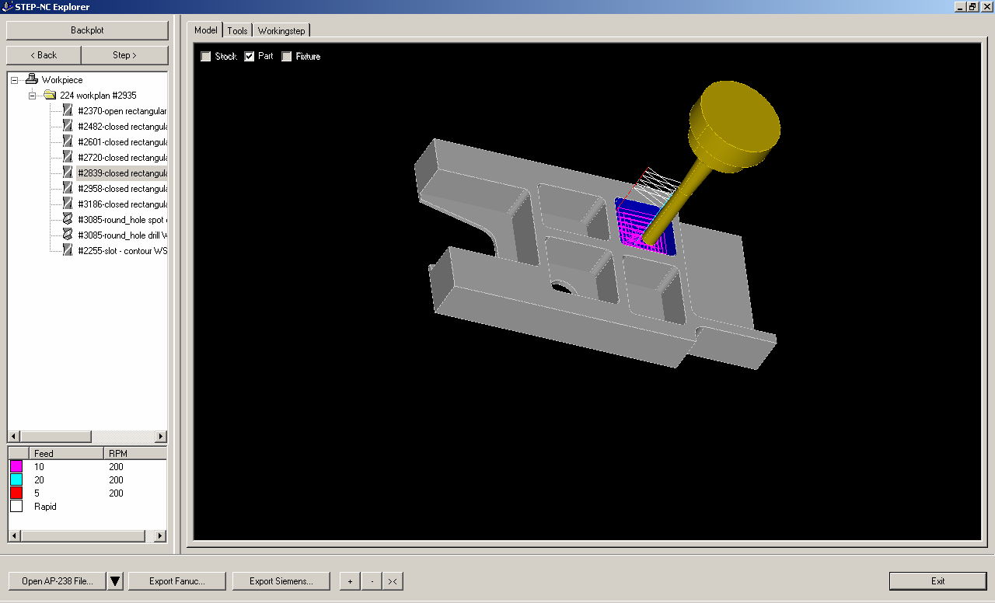
Figure 23 – Feature-based Roughing
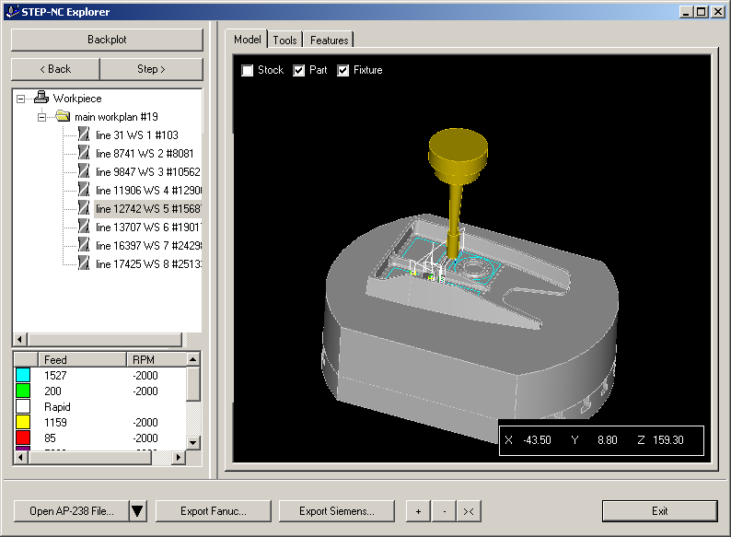

Figure 24 – Finishing Operation
Organizations involved in the demonstration include Airbus, Boeing, CIMPA, LGMT (Laboratoire de Génie Mécanique de Toulouse), LSC, NIST, and STEP Tools, Inc.
Figure 25 –Rough Workpiece
Figure 26 – Finish Workpiece

Other AIM validation
In addition, demonstrations of AP238 AIM implementations were held on:
- STEP-NC Milling Demonstration, 2003 Automation in Shipbuilding Conference. Hyatt Regency New Orleans, New Orleans LA, December 10-12, 2003.
- STEP-NC Milling Demonstration, Bath Iron Works, Brunswick ME, November 12, 2003.
- STEP-NC Milling Demonstration, Northrop Grumman Ship Systems, Ingalls Operations, Pascagoula MS, October 22, 2003
- Super Model Project, 7th Industrial Review Board Meeting -- New Horizons in CNC Surfacing and Probing, National Institute of Standards and Technology (NIST), Gaithersburg MD, June 4, 2003.

