Installation Guide for CAMWorks 2007 FlexLM License Manager

1. Install CAMWorks License Manager
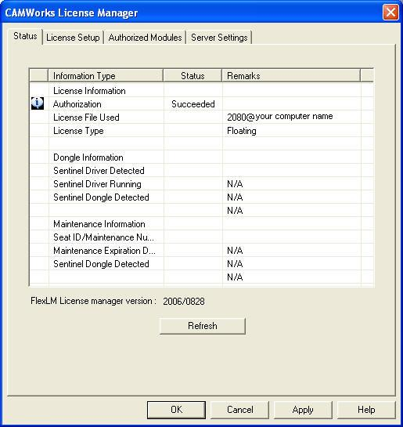
2. Click License Setup tab
License method: choose FlexLM Software
In Configure FlexLM License, choose Set Host name and Port number of floating license
Host name: use your computer name
Port number: use 2080
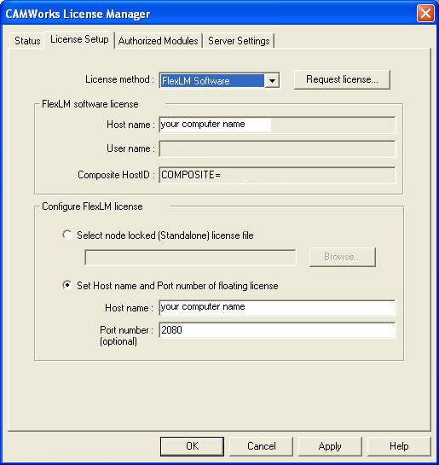
3. Server Settings tab
Choose License file path and Log file path. Before setting, copy license file teksoft.lic into FlexLM license manager folder.
Click Install CAMWorks license service. After that, Click Start.
Now CAMWorks FlexLM License Server is running.
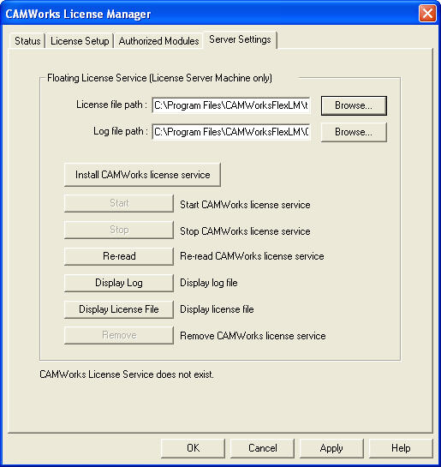
4. Click Authorized Modules tab to show you all the license features are running.
5. Click OK to exit.
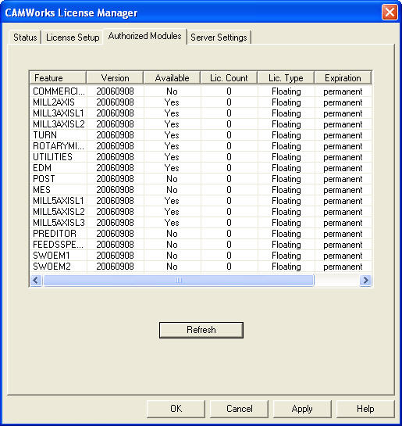
6. Start Solidworks 2007, click Tools and choose Add-ins.
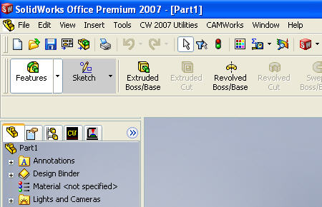
7. Check CAMWorks 2007 and CAMWorks 2007 Utilities for Active Add-ins and click OK
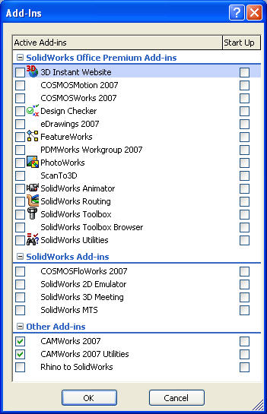
8. Now CAMWorks 2007 and Utilities are working.
9. Enjoy!

Licensed by XZWLYX
